 | Code Compliance Guideline
 | Mobile Food Vending Unit Safety Inspection
 | Fire Inspection Bureau  North Charleston Fire Department  Fire Inspection Bureau  P.O. Box 190016  North Charleston, SC 29419  Office: 843-740-2622  www.northcharleson.org | Issued: 01/10/2022
 |  | Revised: 03/01/2024
 |  | **Permit Required**

Our goal is to ensure that mobile food vending operations are conducted in a safe manner and to help the continued safe operations of the business while reducing potential hazards that may threaten public safety. Routine inspections will be conducted for mobile food vendors to identify and eliminate basic fire hazards and educate vendors on potential risks while promoting a safe and livable community.

South Carolina Fire Code:
The 2021 South Carolina Fire Code (SCFC) included mobile food vendor regulations and was mandated for statewide adoption on January 1, 2020. A self-survey has been created to assist you with achieving and maintaining compliance with the common issues impacting mobile food vendors. Some of the significant changes contained within the latest editions of the code include:
• Operations that produce grease-laden vapors will require installing an exhaust hood protected by an automatic fire extinguishing system.
• LP-gas alarms will be required in an MFV unit mounted between 4 and 20 inches from the floor and within 5 feet of the LP-gas cooking components.
• Fuel gas systems shall be inspected annually by an approved inspection agency

Application:
Interested vendors should complete the fire permit application for Mobile Food Vendors online at the website listed below and attach all the requested documentation to the online application. Our goal is to process the application within ten business days and then schedule your inspection.

https://www.northcharleston.org/government/fire-department/fire-inspections/

Operational Permit:
The mobile food vendor operational permit is intended to assist the vendor in conducting a safe operation while complying with the South Carolina Fire Code. Inspections will be conducted as part of the initial mobile food vendor operational permit application. An operational permit is required before a Mobile Food Vending Unit is operated within the City of North Charleston and must be renewed by April 30 of each year thereafter. Permitted units are subject to inspection when the mobile food vending unit operates.

Category of Mobile Food Vendors:
A | Mobile Food Vendors operating from a cart, trailer, vehicle, or similar who are not cooking or warming food and do not utilize any portable power, propane, or natural gas.
B | Mobile Food Vendors operating from a cart, trailer, vehicle or similar who only warm or reheat food and/or utilize portable power or fuel systems.
C | Mobile Food Vendors who conduct Mobile Food Preparation and cook food (produces grease-laden vapors) and/or portable power or fuel systems.

Approvals:

All mobile food vending unit inspections will be conducted at City Hall by appointment only. Upon successful inspection, the operational permit sticker will be affixed to the vehicle by the inspector and must remain visible. Additionally, the vendor must acquire and post their City Business License (CBL) and maintain the documentation outlined on the application during all hours of operation.

Permit Renewal:
Operational permits will expire on April 30 of each year and may be revoked prior to expiration for a fire code violation. The mobile food truck operator is responsible for renewing the permit before the expiration date. To renew, follow the same process as a new application by completing the fire permit application for Mobile Food Vendors online at the website listed below and attaching the requested documentation for renewal to the online application.

Only two documents are required to be submitted for an application renewal. This includes the City of North Charleston Business License and the completed self-survey. The Fire Inspector will check all other inspection, testing, and maintenance documents at the time of the inspection. Improper or missing documents will result in a failed inspection. Our goal is to process the application within ten business days and then schedule your inspection.

https://www.northcharleston.org/government/fire-department/fire-inspections/

Please visit our website at www.northcharleston.org for additional information and resources, or contact our office at (843) 740-2625.

Code Guidelines:
Below are guidelines to assist in safely operating a mobile food vending unit. This guideline does not cover every possible item that will be inspected, nor does meeting all the guidelines listed below guarantee that a unit will pass an inspection.

The North Charleston Fire Department (NCFD) inspection is an operational safety inspection of the mobile food vending unit on its inspection date. It is not an approval of the mobile food vending unit’s design, construction, or roadworthiness or an indication of the long-term safety of its combined elements.

All electrical, ventilation, propane/natural gas piping, tanks, fittings, appliances, and systems are advised to be constructed and installed by licensed bonded professionals per NFPA, DOT, and the South Carolina Fire Code (SCFC).

All mobile food vending unit inspections will occur by appointment only at City Hall, 2500 City Hall Lane, and the unit must be ready for operation. All systems may be required to demonstrate cooking, electrical, and ventilation.

Operational Permit Required Paperwork to be uploaded with the application:
- City of North Charleston Business License
- DHEC inspection documentation
- Hood cleaning report semi-annual by a professional company (if installed)
- Hood suppression semi-annual inspection or maintenance report (if installed)
- Fire extinguisher annual maintenance documentation by a licensed service provider
- Photos of all exterior sides of the vehicle
- Photos of the interior of the vehicle
- Photos of the cooking area
- Mobile Food Vendors Fire Safety Self-Survey
- LP-Gas certification paperwork (Annual)

Propane:
- Piping systems, including hoses, shall be pressure tested and proven free of leaks annually by a certified inspector
- Propane/natural gas piping must be constructed and installed in accordance with the manufacturer’s recommendations. Propane/natural gas lines routed beneath an MFVU must be constructed with a rigid pipe. Includes piping to L.P. generators
- Any propane/natural gas line that penetrates a wall/partition must be constructed of rigid piping
- At each point where piping passes through sheet metal or structural member, a rubber grommet or equivalent shall be installed to prevent chafing
- Any propane/natural gas line/connector that is not readily identifiable as its construction or type will not be allowed
- All propane tanks DOT approved (within re-qualification date) not to exceed 200lb total for all tanks. Painting of tanks that obscure tank manufacturing or qualification information will not be approved
- All tanks are securely mounted, with metal, to the exterior of the vehicle
- There are no quick disconnects on any exterior propane tanks (quick disconnects on chassis-mounted tanks may be allowed)
- No copper lines connected to LPG tanks
- Rubber propane hose from regulator to tank stamped “Approved for L.P. Gas 350 psi”.
- Moveable-grade, braided, PVC-coated, 304 stainless steel commercial gas connector designed for use with moveable equipment and caster-mounted equipment that is moved regularly for cleaning and repair (See Photos page 6)

Extinguishers:
- At least one 2A:10BC portable fire extinguisher in the unit.
- One 1.5-gallon Type “K” extinguisher is required when cooking operations produce grease-laden vapors.
- Deep frying - one 1.5-gallon Type “K” extinguisher is required for every four fryers
- Extinguisher visible, readily accessible, and mounted
- Each fire extinguisher is maintained per SCFC 906
- Fire extinguishers shall bear a current inspection tag validated within the past twelve months, or a purchase receipt within the last 12 months shall be available for inspection.

Truck/Trailer Ventilation:
- Cooking equipment that produces grease-laden vapors shall be provided with a kitchen exhaust hood in accordance with SCFC 607
- Hood systems shall be of commercial-grade
- Cooking equipment shall be protected by automatic fire extinguishing systems in accordance with SCFC 904.12
- Hoods, grease-removal devices, fans, ducts, and other appurtenances shall be cleaned at the following intervals as required by SCFC 607 by a qualified company

TYPE OF COOKING OPERATIONS | FREQUENCY OF INSPECTION
High-volume cooking operations such as 24-hour cooking, charbroiling or wok cooking | 3 months
Low-volume cooking operations such as places of religious worship, seasonal businesses and senior centers | 12 months
Cooking operations utilizing solid fuel-burning cooking appliances | 1 month
All other cooking operations | 6 months

- In addition to the intervals above, if during any inspection it is found that hoods, grease-removal devices, fans, ducts, or other equipment have an accumulation of grease, such components shall be cleaned qualified company before cooking continues
- All trucks/trailers must be equipped with a working adequate ventilation system. Small - trailers will be evaluated for adequate ventilation on a case-by-case basis.

Cooking Appliances:
- All cooking appliances must be listed by an approved agency for mobile applications for the appropriate fuel and be clearly marked with the appropriate rating sticker
- All deep-fat fryers shall be installed with at least a 16-inch space between the fryer and surface flames from adjacent cooking equipment, or a steel or tempered glass baffle plate shall be installed at a minimum of 8 inches in height between the fryer and surface flames of the adjacent appliance
- Movement of appliances with casters shall be limited by a restraining device installed per the appliance manufacturer’s installation instructions. (See Photos on page 6)

Detection Systems:
- All food trucks/trailers utilizing LP-Gas shall have a UL-listed LP-gas alarm installed within the MFV unit and mounted between 4 and 20 inches from the floor and within 5 feet of the LP-gas cooking components in accordance with the manufacturer's instructions.

Signage:
- No Smoking signs shall be clearly visible and of contrasting colors and shall be readable from 25 feet.
- Signs shall indicate the type of fuel present (1) “PROPANE’” (2) “NO SMOKING”

Electrical:
- All wiring should meet commercial restaurant standards
- No exposed wiring
- Installed per NEC 70

Egress/Exits:
- One egress/exit must be adequate and unencumbered by storage, appliances, or design.

Generators:
- It must be safely guarded from the public right of way.
- If mounted, the generator must be securely mounted and shall not impact propane/natural gas systems

Flammable and Combustible Fuel Storage:
- On-site fuel for generators must be kept in a U.L. Listed Type I or Type II Safety Can
- The maximum size of one individual container is 5 gallons
NCFD does not endorse any one manufacturer of fuel storage containers - photo are for illustration purposes only.
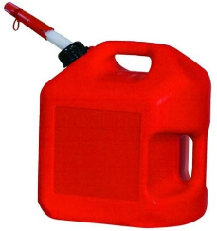 | 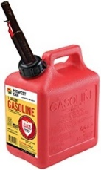 | 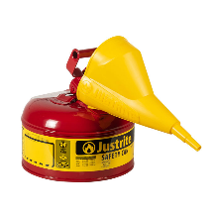 | 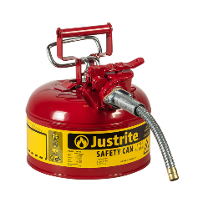
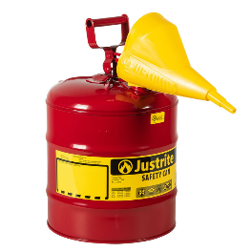 | 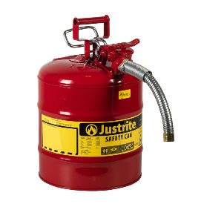 | 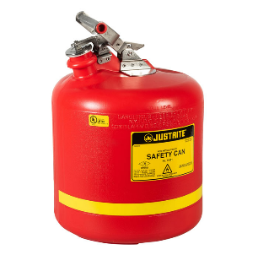 | 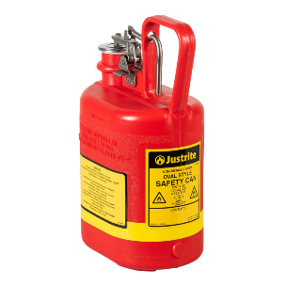

Commercial Gas Connectors Required:
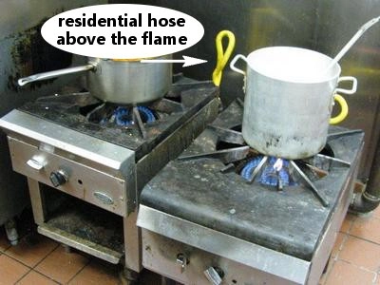
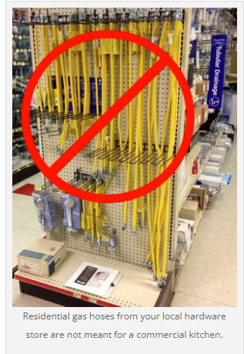

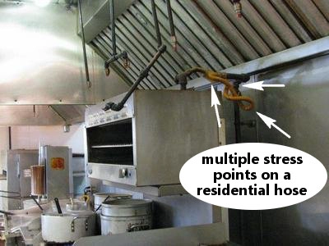

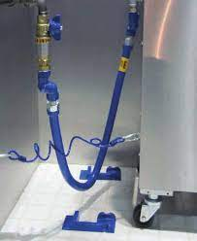

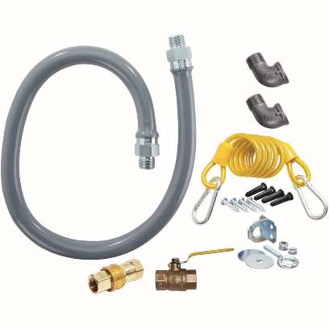

NCFD does not endorse any one manufacturer of gas connectors - photo are for illustration purposes only.

LPG Tank Re-certifications:
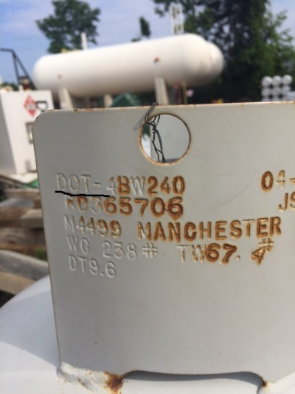
If you have a DOT propane tank, it must be re-qualified after 12 years of manufacture date. Smaller portable propane tanks from 5 lbs to 420 lbs or 1 gallon to 120-gallon tank can be transported over the highways and roads are regulated by The Department of Transportation. If it is a DOT tank, it will be stamped on the outside collar of the tank. It will say “DOT-”

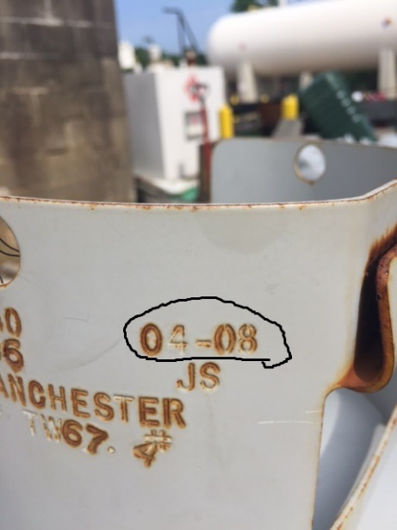
Once you establish you have a DOT tank, the next step is to find the manufacture date. Once again, it is stamped on the tank collar. Per DOT regulations, tanks must be recertified every 12 years from the date of manufacture and every 5, 7, or 12 years thereafter, depending on how the last certification was performed.

Types of Requalification
A tank can be requalified by visual inspection. Only a qualified technician can perform this test. If this test is completed, It will need to be retested 5 years after this date.

Another way to requalify a tank is to perform a “Proof Pressure,” where the tank is tested with air at twice the marked service pressure. If this test is completed, it must be retested 7 years after this date.
This tank would need to be requalified on 4/2020

The last test is a “Volumetric Expansion” test, a water jacket hydrostatic test where the tank is tested twice the marked service pressure. Tanks will need to be re-qualified 12 years after this type of testing.

After a certified technician requalifies a tank, they will mark the tank with the date and type of test performed.

Most MFV Units are using DOT tanks and will need to be requalified 12 years after the manufactures date is stamped on the collar of the tank. If your tank is approaching the recertification date, take it to your local propane dealer, who can provide further directions. You may not get your tank tested and filled immediately, but you should be able to exchange the tank.

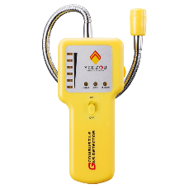
Additional Recommendations
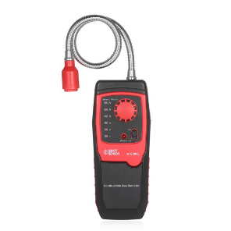
- A daily propane system leak check should be performed before putting the unit into service, after any movement of the vehicle, and after movement/change or addition of any gas-fed appliance. These leak checks should be performed with a hand-held listed flammable gas leak detector.

- All MFV Units with LP gas should have a hand-held listed flammable gas leak detector to test for leaks anytime the LP-Gas containers are changed and before placing the MFV unit into service.

NCFD does not endorse any one manufacturer of gas leak detector - photo are for illustration purposes only.

